**LCD DISPLAY TO SHOW “HELLOW WORLD”**

Description: In this project, we will print “HELLOW WORLD” in LCD display.

Hardware requirement :

* Lcd display(16X2);
* Potentiometer
* Breadboard
* Jumperwire
* Arduino Uno board

Connection:

* Lcd’s VSS connected to arduino’s 5V power supply
* Lcd ‘s VDD connected to GND
* Lcd’s V0(contrast) connected to potentio meter’s middle terminal as contrast.
* Lcd’s RS(resistor select) connected to Arduino’s pin-2
* Lcd’s RW(read/write)connected to GND
* Lcd’s E(Enable) connected to Arduino’s pin-2
* Lcd’s D4 connected to Arduino’s pin-3
* Lcd’s D5 connected to Arduino’s pin-3
* Lcd’s D6 connected to Arduino’s pin-3
* Lcd’s D7 connected to Arduino’s pin-3
* Lcd’s A(anode) connected to Arduino’s 5V power supply through resistor
* Lcd’s k(kathod) connected to ground
* Potentiometer’s one terminal connected to Power Supply.
* Potentiometer’s middle terminal connected to LCD’s V0
* Potentiometer’s another terminal connected to GND.

Circuit Diagram:

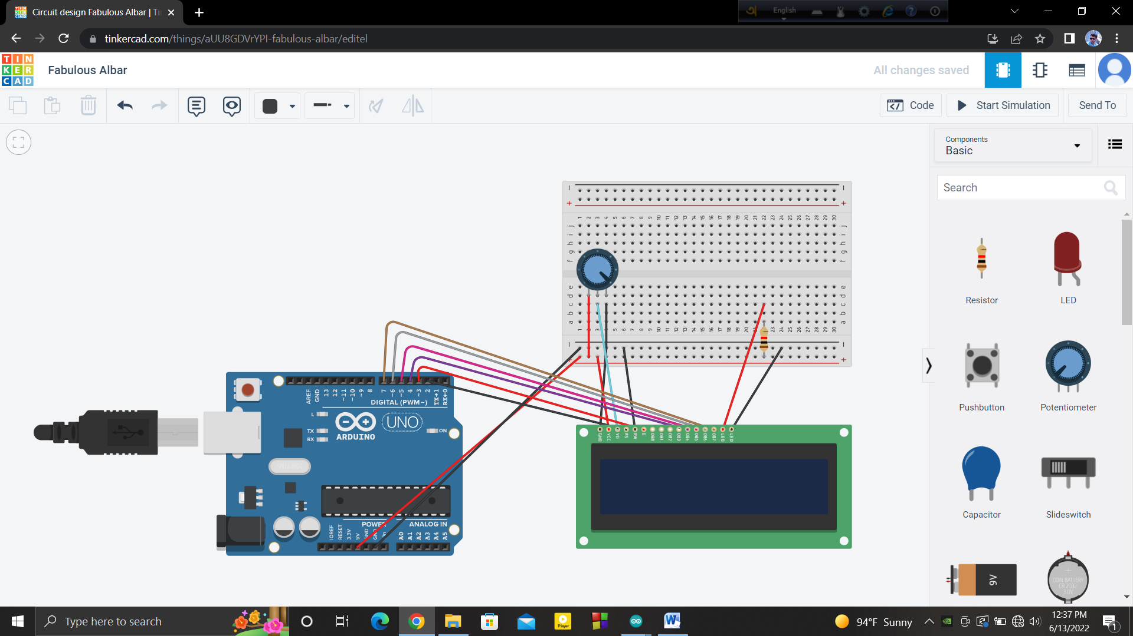

Code:

|  |
| --- |
| #include<LiquidCrystal.h> LiquidCrystal lcd(2,3,4,5,6,7); void setup() { lcd.begin(16,2); }   void loop() { lcd.setCursor(2,0); //(col, row)   lcd.print("hellow world"); } |